VORA Navigation and Routing Flow
Below are comprehensive flow diagrams representing the navigation structure and available pages for vora application, mapped out according to the authentication state and user roles (admin, expert, company, user).

1. High-Level Routing & Auth Flow
This diagram illustrates the entry point of the app where the system decides what routes the user can access based on their authentication status and assigned role.
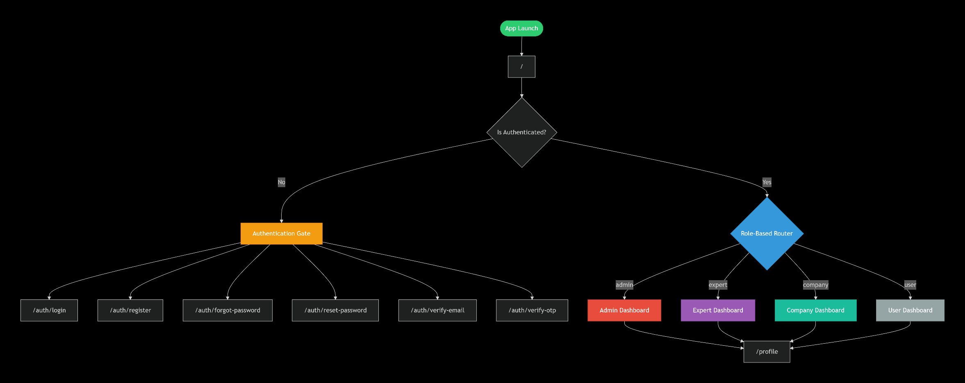

2. Admin Navigation Flow
Admins have access to system-wide framework management, user management, and an admin dashboard.
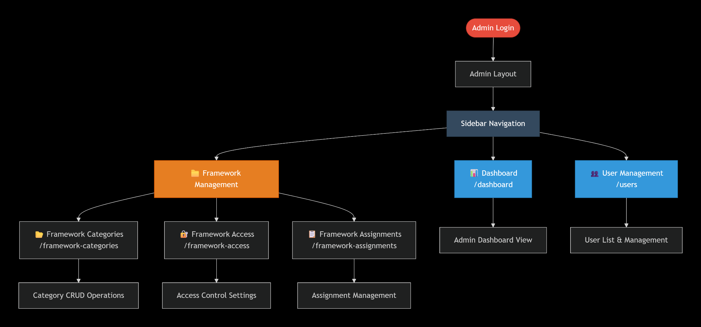

3. Expert Navigation Flow
Experts have access to framework details, deployment frameworks requests, and their own dashboard.
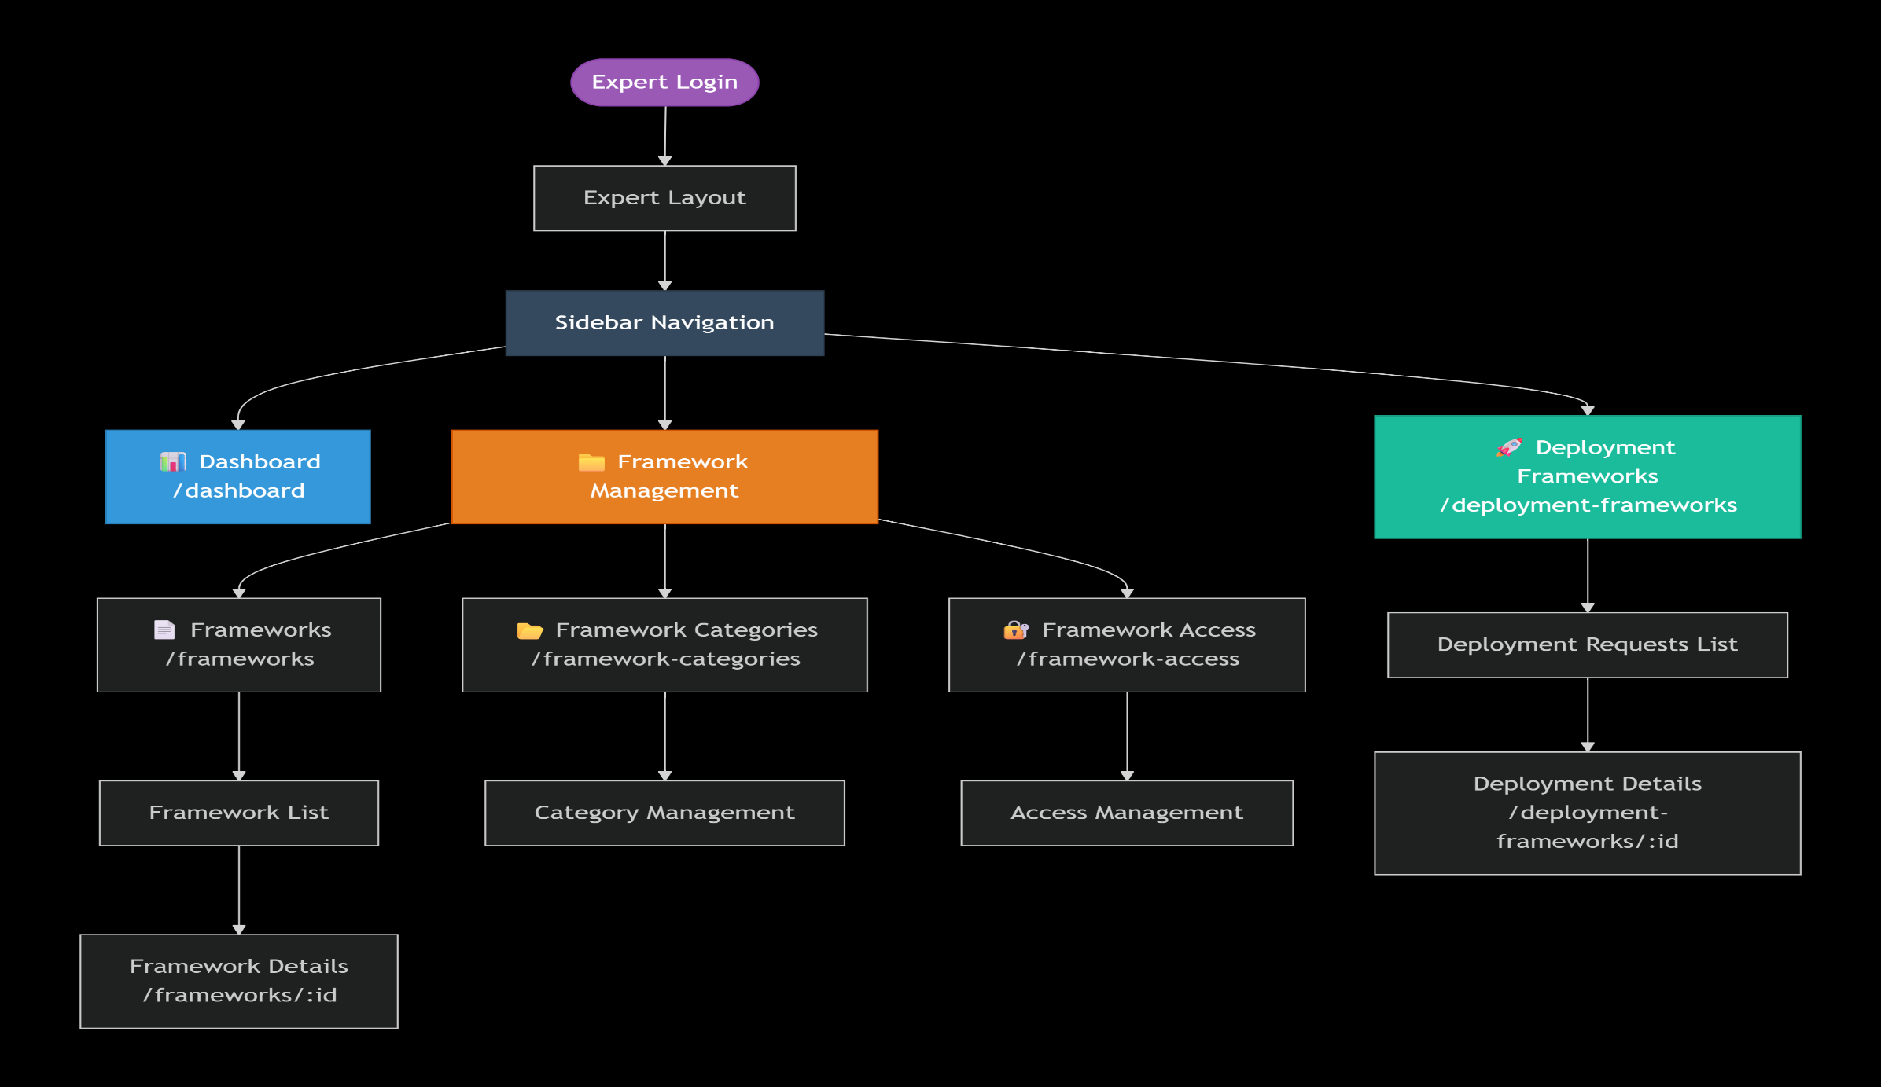

4. Company Navigation Flow
Company users can manage their own nested users, oversee framework deployments assigned to them, and manage deployment documents.
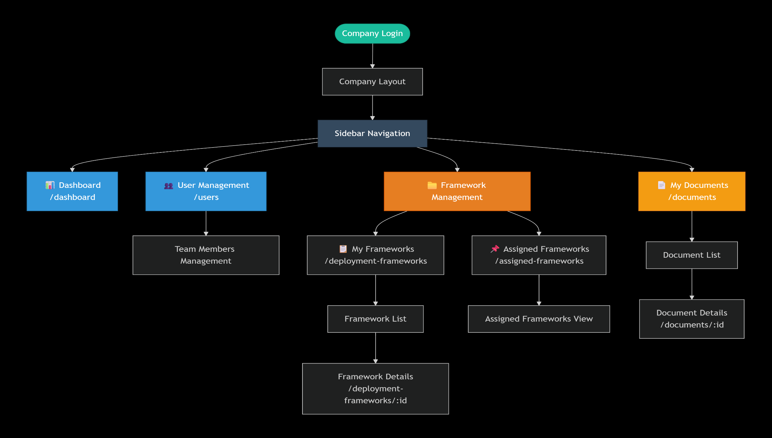

5. End User Navigation Flow
Standard users have access to a simplified dashboard and their documents view.
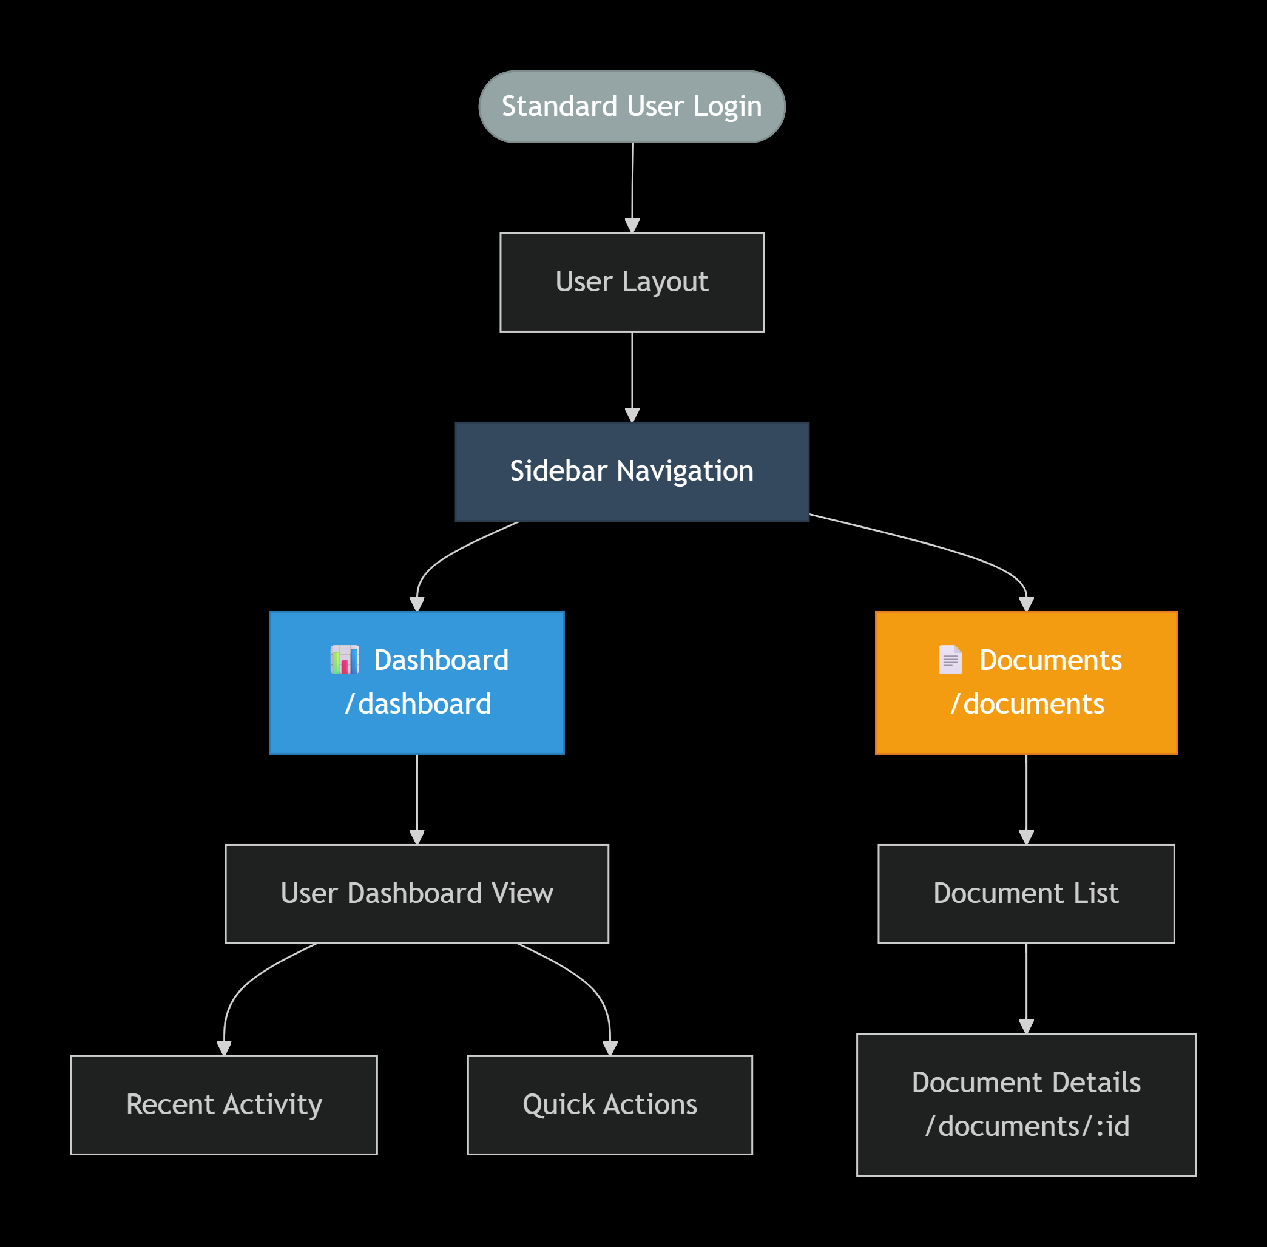

Prepared By: Saksham Kamboj
Date: 1st April 2026

